2-Bromo-3-MethylButane
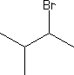
Main Function Group: Alkyl Halide
- Common Name – 2-Bromo-1-MethylButane
- IUPAC Name – 2-Bromo-1-MethylButane
- Molecular Weight –151.04 g/mol
- Melting Point – N/A
- Boiling Point – 29.8°C (304.2 K)

